1. Explain the working of website.
2. Illustrate the structure of website.
3. Differentiate between Web Hosting & Web Publishing.
4. Illustrate the steps involved in Web Publishing.

**website**

A **website** (also written as a **web site**) is a collection of [web pages](https://en.wikipedia.org/wiki/Web_page) and related content that is identified by a common [domain name](https://en.wikipedia.org/wiki/Domain_name) and published on at least one [web server](https://en.wikipedia.org/wiki/Web_server). Examples of notable websites are [Google](https://en.wikipedia.org/wiki/Google_Search), [Facebook](https://en.wikipedia.org/wiki/Facebook" \o "Facebook), [Amazon](https://en.wikipedia.org/wiki/Amazon_(website)), and [Wikipedia](https://en.wikipedia.org/wiki/Wikipedia).

**How the web works**

## How the web works provides a simplified view of what happens when you view a webpage in a web browser on your computer or phone. [Clients and servers](https://developer.mozilla.org/en-US/docs/Learn/Getting_started_with_the_web/How_the_Web_works#clients_and_servers)

Computers connected to the internet are called **clients** and **servers**. A simplified diagram of how they interact might look like this:

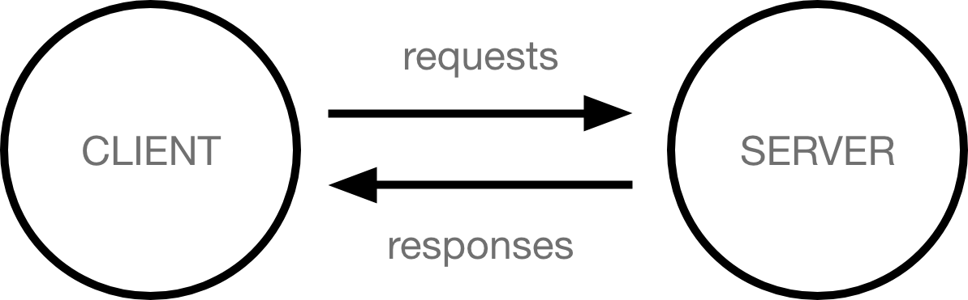

* Clients are the typical web user's internet-connected devices (for example, your computer connected to your Wi-Fi, or your phone connected to your mobile network) and web-accessing software available on those devices (usually a web browser like Firefox or Chrome).
* Servers are computers that store webpages, sites, or apps. When a client device wants to access a webpage, a copy of the webpage is downloaded from the server onto the client machine to be displayed in the user's web browser.

## In Short

We have seen how a Web client - server interaction happens. We can summarize these steps as follows −

A user enters a URL into a browser (for example, [Google.com](http://www.google.com/). This request is passed to a domain name server.

The domain name server returns an IP address for the server that hosts the Website (for example, 68.178.157.132).

The browser requests the page from the Web server using the IP address specified by the domain name server.

The Web server returns the page to the IP address specified by the browser requesting the page. The page may also contain links to other files on the same server, such as images, which the browser will also request.

The browser collects all the information and displays to your computer in the form of Web page.

How do websites work?

Before you begin creating your own website and launch it to the Internet, it’s important to know how websites work.

Here are some basic terms:

* A **website** is simply a collection of web pages of codes – codes that describes the layout, format and content on a page.
* The **web server** is a internet-connected computer that receives the request for a web page sent by your browser.
* The **browser** connects your computer to the server through an IP address. The IP address is obtained by translating the domain name. (*Don’t worry, this part is all done automatically by your browser so you don’t have to look up the IP addresses yourself.*)

In other words, in order to display your website on the Internet, you will need:

* A website
* A domain name
* A server

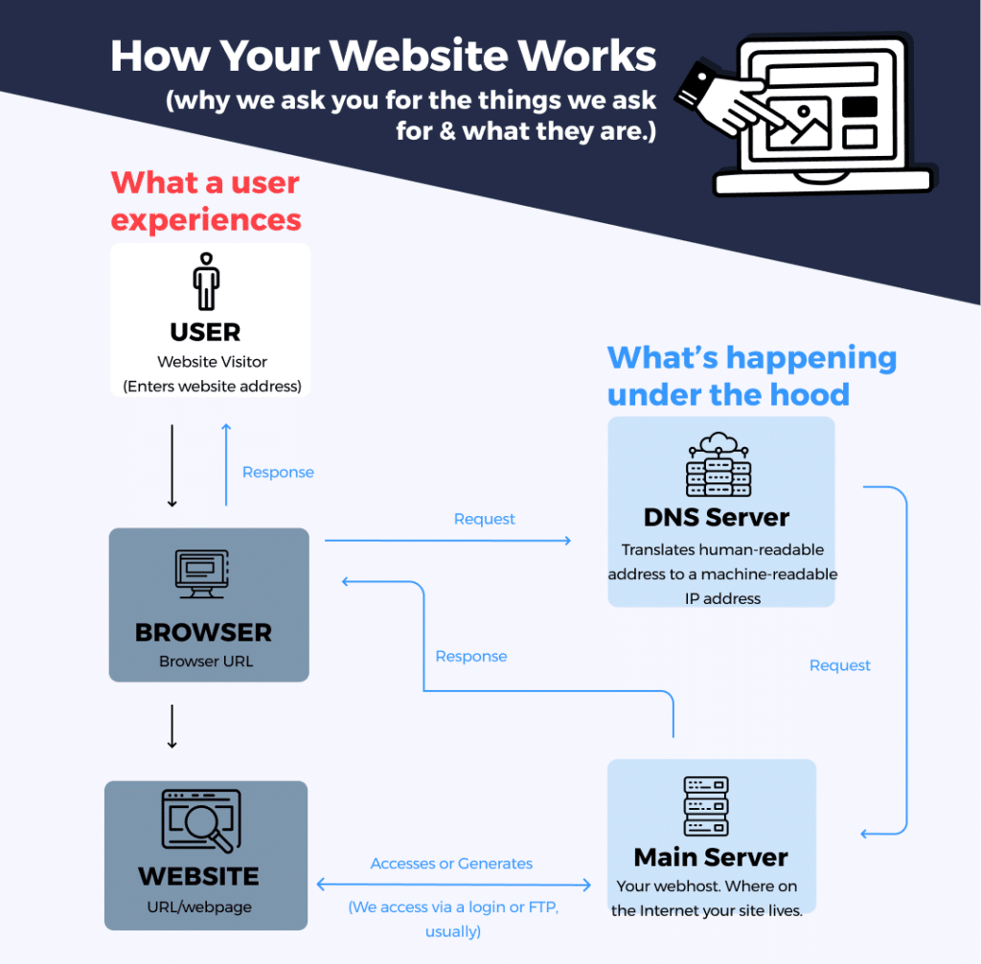

**How the Web Works**

• What happens when you request a web page?

• A file is delivered back to your computer and interpreted by your Web

browser.

• What is the difference between browsers such as Internet Explorer,

Safari, Chrome and Firefox? What do they all basically do?

• Browsers request text files (saved with special “html” file extensions),

read the file, and then graphically display the contents.

• What is html? Pages are “text and tags”. You can view the “source” of

any web page to see that text file behind the page. But who would

want to view a “web page” in that “code” mode?

• What does it take to create a web page?

• It is possible to take a whole bunch of text, save it as a file with an html

extension (text.html), and view it in a web browser. But it’s just a large

wall of text with no formatting.

• To apply formatting/design, HTML tags are used for formatting text,

placing images, creating hyperlinks, etc.